Rotary Hook info and Hook Timing Adjustments

[Bill Garvin on Rotary Hook Burrs](https://www.youtube.com/watch?v=Fw7MIWAaqbY)

For this training you will need:

rotary hook with damage

80 grit sandpaper

1000 grit sandpaper

Rotary Hooks are made of 4 pieces. Keeping an extra one on hand is smart. They have a lifespan of generally 10 years. Broken needles can cause damage to a rotary hook by causing burrs.

**Burrs can cause missed stitches, loops and fraying thread.**

Anytime a needle breaks, blow out the rotary hook with compressed air, clean out the tension spring on the bobbin case, run fingernail across edge of rotary hook to check for burrs and alert manager.

When checking for burrs, think of the rotary hook in 3 dimensions. Use your finger nail to feel for a rough edge or shining a flashlight can help identify burrs. If a burr is present, use 1000 grit sandpaper to polish it away. If it is very deep, use 80 grit first then 1000 grit to polish. Great news, you can’t over sand a rotary hook! After you have polished it back to smooth, blow out the rotary hook with air and oil it.

[Bill Garvin’s Hook Timing Tutorial](https://www.youtube.com/watch?v=oIeMvyZ2GHk)

[Hirsch’s instructions](https://drive.google.com/open?id=1SrDpPdNWAUVli9wDuUlwtdLhgvxa12f_)

[How to use RhAT tools to doing timing adjustments](https://youtu.be/bDgogoPxcEQ) (we don’t have these, yet.)

Things that commonly mess up your timing:

* Hitting the hoop
* Birdsnest
* Broken Needle
* Not enough oil

If you are adjusting the timing, you want to set the timing on the center needle (for example 15 needles, set on needle 8).

Hitting the vertical center of the scarf can be a little forgiving (a few degrees higher or lower), but people usually mess up on the deflection (how close the point of the rotary hook is to the scarf).

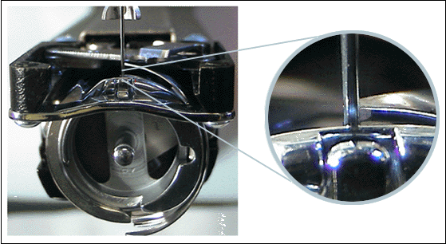

Target distance between the two is .3 to .5 mm (the width of a sheet of paper). A trick is to turn the needle backwards (scarf facing toward you) and bring the rotary hook’s point to the needle. Then when you turn the needle right again, the indentation of the scarf is usually about a paper’s width away.

A tip for making sure the multihead machine doesn’t stray from the right degree:

Push the needle holder (not presser foot) until it locks the needle down. Now only this head’s needle will move as you rotate the machine. Rotate the gauge until the needle is in the correct position (Our single heads 200°) and then use a binder clip to hold the needle still. (add picture)